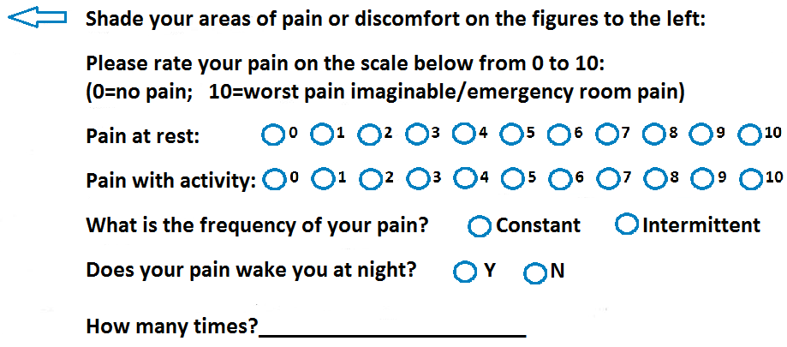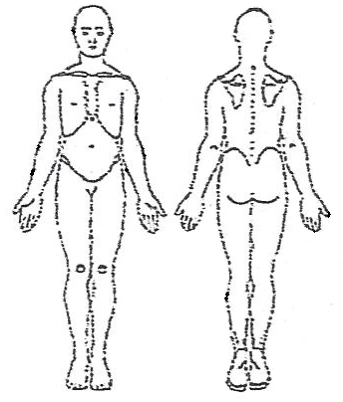

**MEDICAL QUESTIONNAIRE**